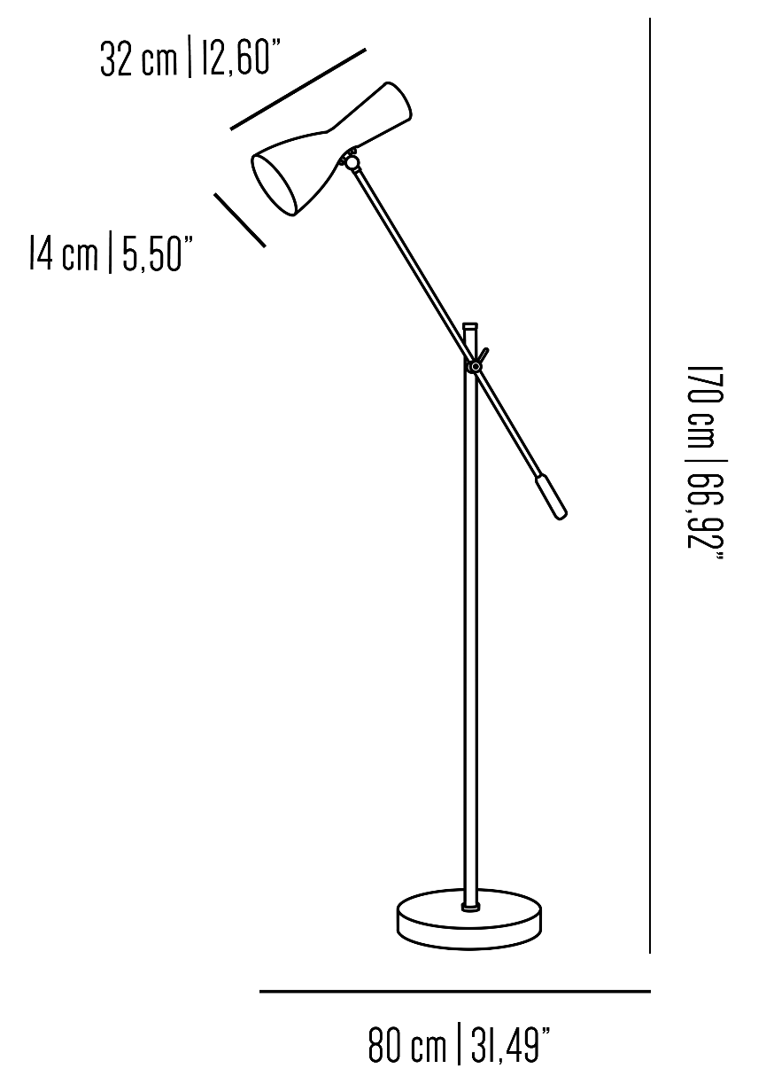

**BB_WOR01Jp**

Floor lamp with brass structure and jointed arm.

Painted aluminium lamp shade and marble base.

Incandescent source: 1 x G9 max 18 W + 1 x E27 max 42 W

Weight: 11 kg

Collection: Brass Brothers & Co.