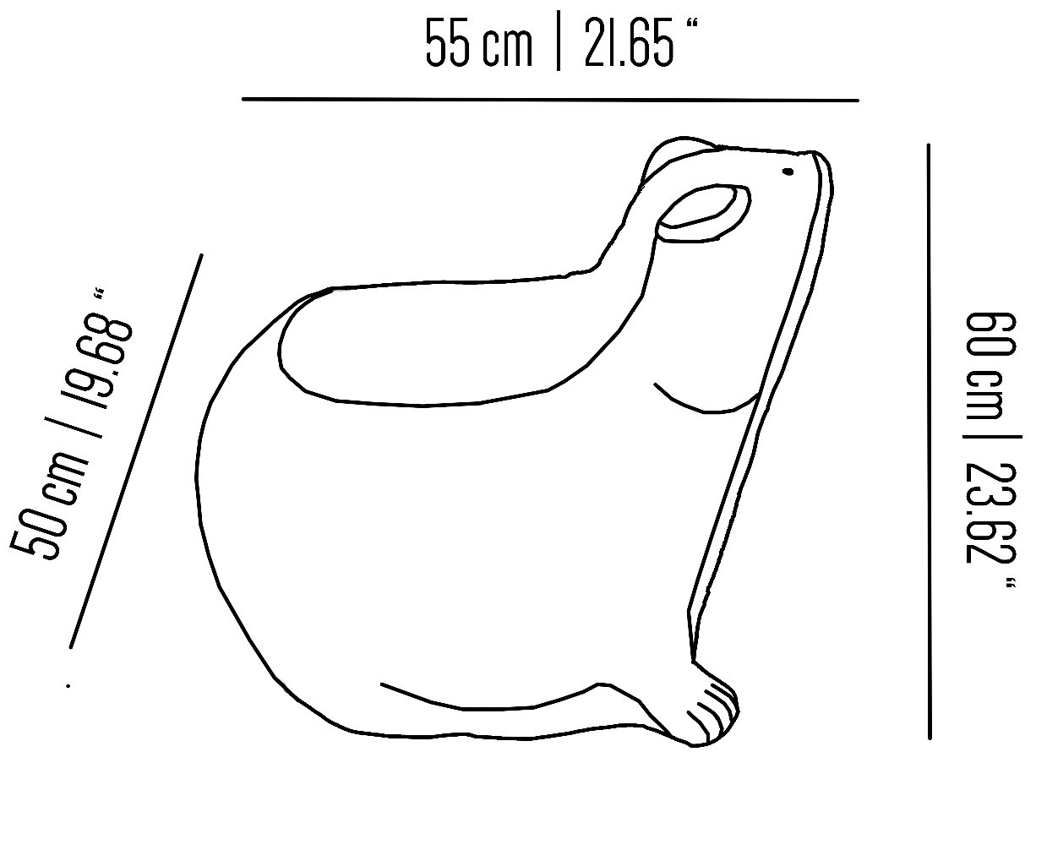

**EC_BES08st_B_BLUE**

Ceramic frog chair

Collection: Brass Brothers Eclectic